DairyBISS has successfully conducted its 4th Dairy Business Platform on breeding.

On the 19th of December 2017, DairyBISS has successfully conducted its 4th platform on breeding specifically on improving private AI service to commercial dairy farms, at the Ambassadors hotel in Addis Ababa.
The meeting aims to bring together stakeholders in Ethiopia dairy sector to discuss on improved dairy fertility management with specific focus commercial dairy farm and effective private AI services provision that is playing a vital role in fertility management and breeding in the country. The meeting was aimed to provide an advice to government in dairy breeding strategy development as well as representatives of development partners including DairyBISS on best steps forward to support efforts for realization of improve breeding for dairy production in Ethiopia.
The platform involved over 30 participants including commercial dairy farms, private AI service provider companies, private AI technicians, government and development partners.
Three presentations delivered, the first presentation which was made by Dr. Dereje Shiferaw director of Ethiopia National Artificial Insemination Centre. His presentation was focused on AI service provision from experiences Ethiopia National Artificial Insemination Centre. He briefly explained challenges and opportunities of AI service on Ethiopia dairy sector.
He said that “The AI service has been given little or no emphasis over the past years as a result of which efficiency and success has been severely impaired this while being a problem also offers various opportunities such as the growing demand for reliable services and quality semen.” It is observed that commercial farms as well as smallholder farms are willing to pay higher fees per service provided that if they get quality semen from reliable services. In addition there is a possibility of getting alternative semen sources. The government has been given big attention for the sector for this there are nationally established systems and national organizations to coordinate efforts. To this effect, the government launched breeding policy and work to restructure National Artificial Insemination Centre to Institution level for smooth implementation of the breeding policy and strategy policy. As far as challenges go there is inefficient coordination at national level and poor linkages among major actors along with little attention to the overall AI operation, then there is high turnover of skilled AIT’s because of lack of appropriate career structures in all regions. There is also an absence of herd recordings scheme and lack of appropriate bull selection based on progeny testing methods, the final two are absence of monitoring and evaluation and limitations in animal health service delivery.

The second presentation was made by Dr. Emiru Zewede, manager of ALPPIS (Addis Livestock Production and Productivity Improvement Service). He shared the experience of his company in providing AI services for dairy farms. He briefly explained about the growing demand for alternative quality semen supply and reliable AI services, also farms are willing to pay for the service if they prove the services are effective and reliable. Then there is an interest for coordinated approach between public and private sectors service providers. The government and NGO’s have an interest to support the private sector development. Even if the opportunity is immense to provide AI service in private sector, he briefly discussed on the following challenges:- limited resources for investment and operational expenses, unfair competition with highly subsidized government AI services, shortage of practicing private AI technicians such as government AI technicians afraid to incorporate private semen in their delivery, luck of strategy for coordinated PPP approach, and credit facilities not easily available and unreliability in the supply of liquid nitrogen and foreign currency.
The third presentation was on experinces of commercial dairy farms by Wondriad Abraham chair of commercial dairy producer association tried to assess AI services and challenges in building the future generation of dairy cows. He mentioned that there is a gap in knowledge and skills of dairy farm to utilize AI service effectively. He mentioned lack of skill and knowledge in dairy farm management directly imply on effectiveness of AI services. He also mentioned that the current AI service in Ethiopia exclusively focus on foreign and imported semen. AI service has been provided by companies without considering the needs and priorities of dairy farms. Access to information regarding the AI service is very limited and no proper consultation at all. Accountability of AI services providers is low regarding their efficiency. There is also the issue of cumulative adverse effect of service delivery inefficiency which is there because of reluctance of may household dairy farmers to go for “improved breeds”. Then coming to the human factors of AI application there is very low signs of motivation and this leads to low success rates and unreliable services. Next there is also a lack of accountability. This results in an inefficiency leading to the emergence of a “Self-contained” approach which comes in the form of Private companies.
Main issues forwarded for discussions on AI service: the questions are categorized as follows
- Regarding semen quality: - there are high incidence of abortion, cows death during pregnancy, calves blindness and lameness at birth, how we develop trust on quality of semen and ensure this badies happened again.
- Regarding service: farmers haven’t received any information about the AI services. They said receive it blindly and see the result in through time.
- Technical capability of AI technicians:- conception rate is very high ( two to four times are common)
Director of dairy production from Ministry of Livestock and Fishery Development briefly explained the position of the government on AI service provision using the new breeding policy framework. He discussed that the government is supporting stakeholders on semen quality, including its training of well-educated veterinarians to prevent diseases and problems caused by mistreatments including the lamp skin disease LSD. There is also external support is being given in this field, such as Bill Gates. There are set backs and problems such as a lack of research on the breeding, The government believe that attention should also be given to quarantine for semen, a follow up to the supervision and sex semen ,they believe more work is needed as there are efficiency problems . For this the government has a plan to give a two month training in response .They also believe on setting more goals for the future. For their plan they have made two documents one is the Master plan .This plan primarily focuses on Borena and Jersey breeds ,the will focus on making better breeds and not only by crossbreeding .It also focuses on proper selection ,embryo transfer and breeding agenda and diseases. The second document is the EGAD doc which behaves as proclamation drive that extensive focuses on the making of affordable price for commercial farm goods. The other way is by building cooperatives which will focus on problems such as low supply of injections are in short supply, flour farms growth and milk production which we had problems with food supplies.

Following the presentation the Q&A session was going: the main issues are about quality of semen and its performance. The platform shared and received various relates ideas and concepts and questions related to the topic from the participants and discussed certain solutions. Further strategies and plans were also conducted before the conclusion of the meeting.
- There is a need to support private AI technicians in regards to business development and technical issues that aims to address their limitation to deliver the AI service efficiently and effectively.
- There is a need to engage in improving the genetic pool of the country that create an opportunity for commercial dairy farms to access quality semen and diversified genetic sources in the total characteristics index. Note currently the private sector have capacity to supply 50,000+ dose while NAIC supply 1,000,000+ dose.
- There is need to set (PPP) public private partnership to attain the set goal of genetic improvement strategy
- There is need to work on supporting the ministry on some specific details of breeding policy in its implementation phase.
- Support to design business model which trigger private sector involvement through time and able to take over fully the responsibility of government in providing AI services to the public
- Conduct sort of study and recommend business model how lead commercial farm or processing industry could provide embodied services which including AI for dairy farmers.

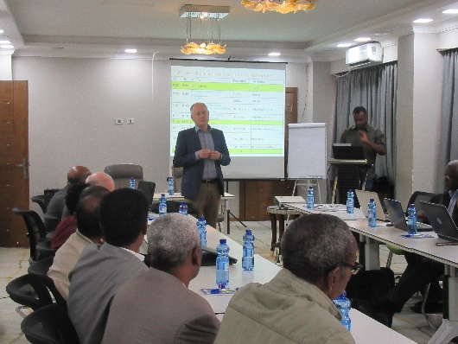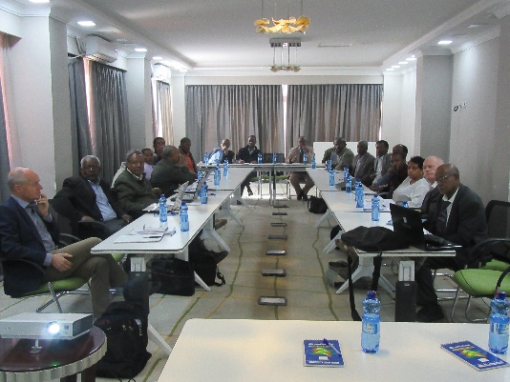
Meeting being conducted.
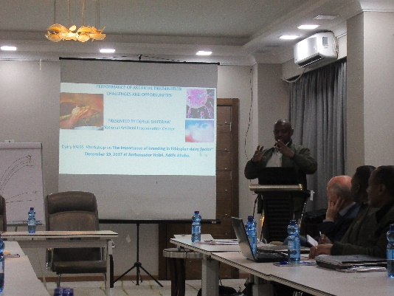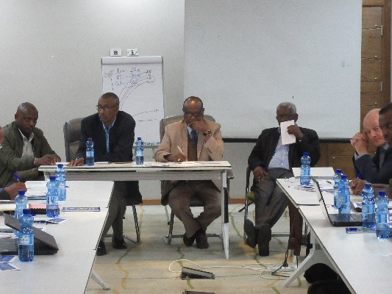
Explanation being given on the benefit of AI and Q&A session.

