Financial sector sheds hope to Ethiopian dairy business

The Dairy sector and financial institutions realise the need for a closer collaboration to develop new finance models that can support the development of the Ethiopian dairy sector. This was agreed by representatives of prominent banks, insurance companies and the dairy sector who attended the 2nd dairy business platform meeting in Addis Ababa on April 7th, 2016 organised by DairyBISS.

‘Closer collaboration with financial institutions is needed to enable successful developments in the Ethiopian dairy sector’, said Jan van der Lee, project manager of DairyBISS Ethiopia. However, banks claim that often sound financial information of dairy business is lacking, especially with start-up businesses. This makes it difficult for banks to make evidence-based decisions on providing financial credits to farmers. ‘DairyBISS will start investigating possibilities for new financing models, together with financial institutions and the dairy sector’, announced Van der Lee.

The current credit crunch prominent in the country has created a grim situation for investors and business owners by disrupting the continuous flow of product along the value chain. Especially for a perishable product like milk - with fluctuating demand, absence of technology and infrastructure, the limited availability of financial services make it difficult for the sector to invest in new developments. Therefore DairyBISS has geared this pressing issue to the business platform meeting in an attempt to provoke innovative, systematic thinking and technology based solutions.

Participants of the meeting proposed the financing of the whole dairy value chain as a better strategy to increasing profitability and improve bank repayment schemes. The banks also acknowledge risk analysis and management as workable tools to deliver better service to the dairy sector. The major discussion points from the sector were related to collateral options and loan repayment flexibility in consideration of nature of the business in the dairy sector. The issues in relation to the liquidity problem in country and the lack of technical expertise among bank professional was clearly admitted as weak points in the quality and efficiency of existing financial services.
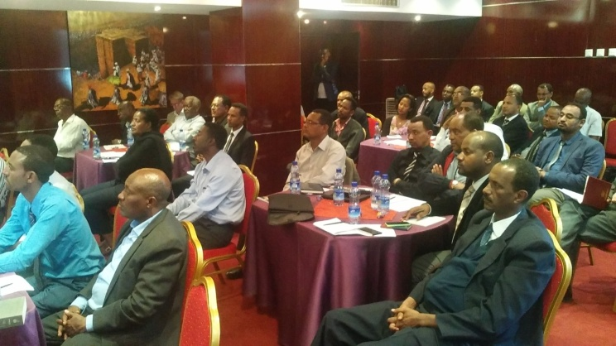

‘The first two things a human being takes upon arrival on this earth is air and milk’

President milk processors association.

High premiums and ensuring goods from country of origin took a forefront challenge which the Insurance sector recognised as problem that can be solved with collaboration, lobbying legislation and information to the client.

The room, after multiple back and forth discussion, came to a consensus that closer working is essential to solve dynamic problems unique to the industry and national disaster like the aflatoxin. Suggestion on lesson learning opportunities among banks and insurance companies could have an effect on quality and efficiency of financial services. As a closing statement DairyBISS announced that the raised ideas are potential inputs for the development of an innovative pilot model project that will be followed by a call of proposal.

